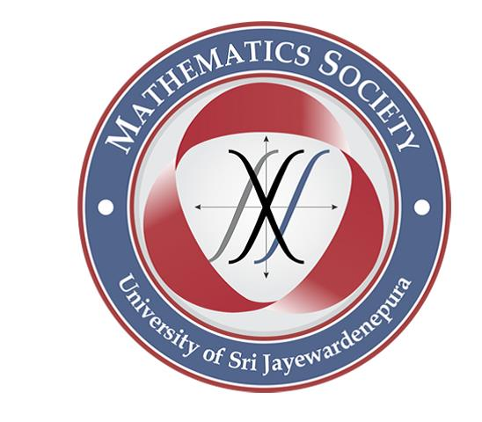

Mathematics Society

of

University of Sri Jayewardenepura

kindly invite you all

to the

guest lecture

on

**“An invitation to Model Theory”**

conducted by

**Mr. Danul Gunatilleka,**

Phd candidate,

University of Maryland,

College Park, Maryland, USA

at **M2** Lecture Theatre

on **January 5th 2018** at **1.00 p.m.**